**MIT Cheetah/ Research**

**HobbyKing Robot Motor**

**AKA SteadyWin V3**

|  |
| --- |
| **Hey SteadyWin**: If you are reading this, **please contact me**. I have many questions and you have failed to respond to many email and support requests. Your product is far from what is advertised. That is OK, but we need some answers to improve the product. |

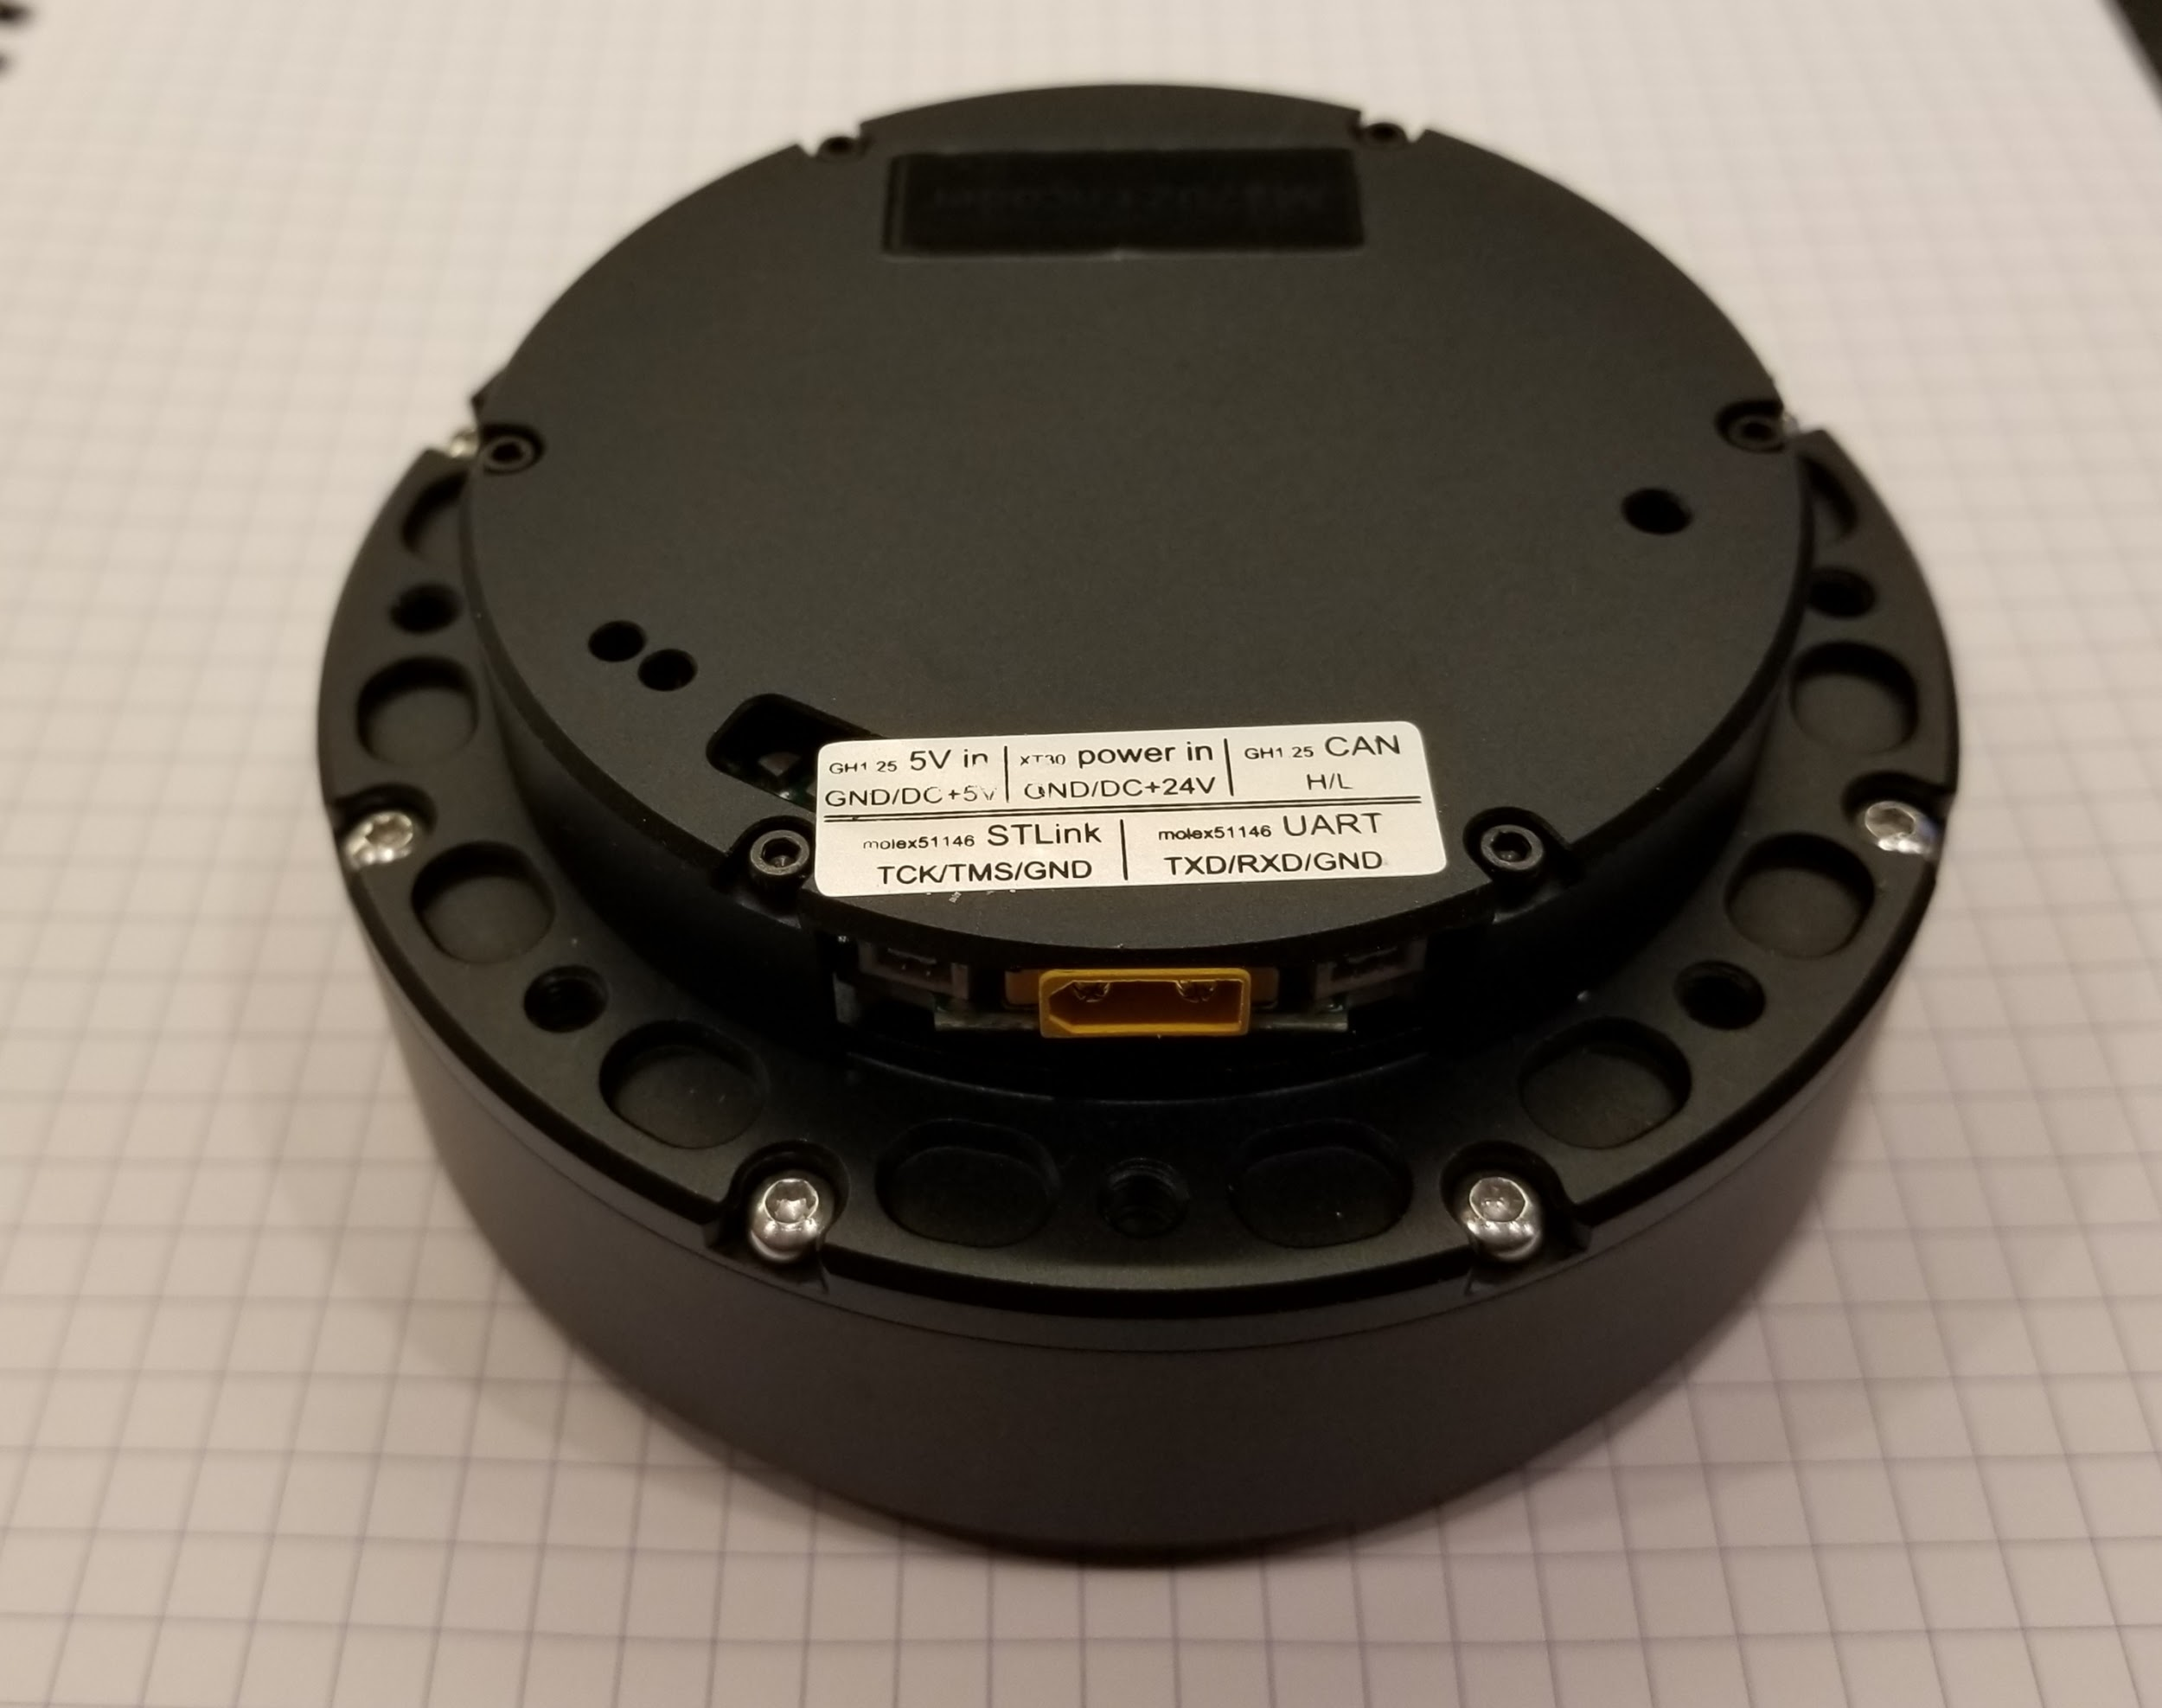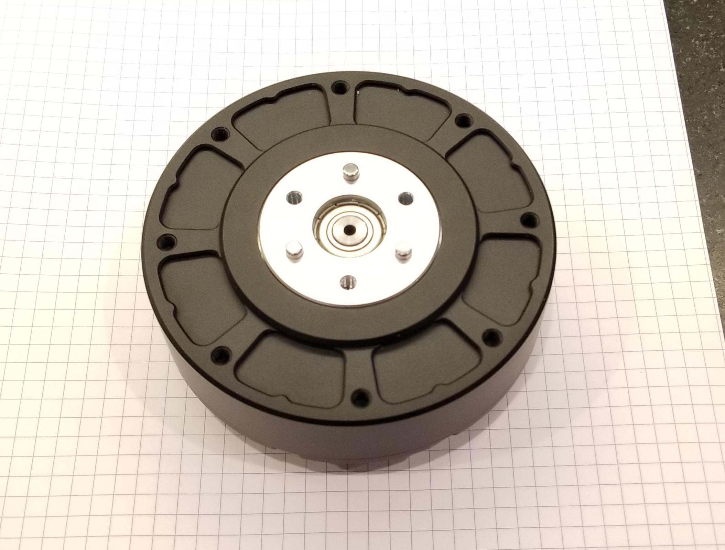

AliExpress Page

Steady Win Company Page

<http://www.steadywin.cn/>

Video of someone using a different model

[https://www.youtube.com/watch?v=ecSQZlNda6g](https://www.youtube.com/watch?v=ecSQZlNda6g&t=2s)

Video of complete Teardown of the motor

<https://www.youtube.com/watch?v=Mhxz2Bj2RXA&feature=youtu.be>

My Videos

<https://www.youtube.com/watch?v=Fb6HQNZ4PzQ>

<https://twitter.com/buildlog/status/1219807520816017409>

<https://twitter.com/buildlog/status/1220372055776022528>

Ben Katz Blog

[Hobbyking Cheetah](https://build-its-inprogress.blogspot.com/search/label/HobbyKing%20Cheetah)

Ben Katz Github

[bgkatz/3phase_integrated: 3-phase motor controller with integrated position sensor](https://github.com/bgkatz/3phase_integrated)

Motor Drive documentation

<https://docs.google.com/document/d/1dzNVzblz6mqB3eZVEMyi2MtSngALHdgpTaDJIW_BpS4/edit>

Controller Schematic PDF

<https://drive.google.com/open?id=1LKZBExanS721uNWVH1Bye9HUD9dOXb_F>

mBed (The Firmware)

[https://os.mbed.com/users/benkatz/code/Hobbyking_Cheetah_Compact/](https://os.mbed.com/users/benkatz/code/Hobbyking_Cheetah_Compact_DRV8323/)

Python Library

<https://github.com/bgkatz/USBtoCAN/tree/master/python%20library>

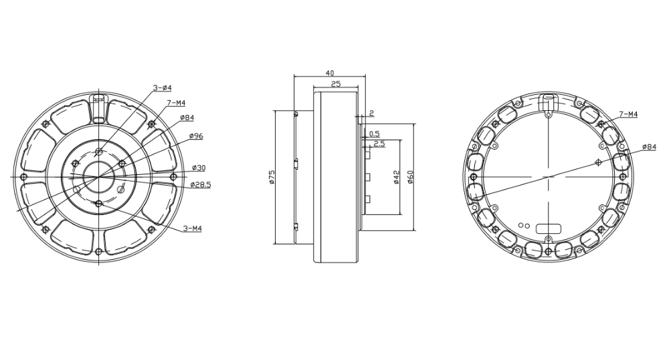

Notes:

The motor will turn on with a red LED. If you enable the motor it will turn green, but the rotor will not lock. If you send it to a position, it will go there and lock.

Parameters

Kp is desired position stiffness. If you set all commands to zero except for Kp, the motor will behave like a spring with stiffness Kp about the 0 angle.

Kd is velocity gain. Kd acts like a damper. If you set all the commands to zero except Kd and try to spin the motor by hand, you will feel some drag, proportional to Kd.

The feed-forward torque is a bias torque. If you set all the commands to zero except for the feed forward torque, the motor will just apply the torque you set.

All the commands get summed up in the motor drive, so the final torque is:

Kp*position_error + Kd*velocity_error + feedforward_torque

Tip: If you want to go at a specific velocity, the Kd should be higher than the kp

Command Packet Structure (CAN Speed is 1Mbps)

The driver uses one packet to combine 5 commands. The commands are:

* 16 bit position command, scaled between P_MIN and P_MAX in CAN_COM.cpp
* 12 bit velocity command, scaled V_MIN and V_MAX in CAN_COM.cpp
* 12 bit Kp
* 12 bit Kd
* 12 bit Feed-Forward Current

|  |
| --- |
| // from … <https://os.mbed.com/users/benkatz/code/Hobbyking_Cheetah_Compact//file/6cc428f3431d/CAN/CAN_com.h/>  #define P_MIN -12.5f // -4*pi #define P_MAX 12.5f // 4*pi #define V_MIN -45.0f #define V_MAX 45.0f #define KP_MIN 0.0f #define KP_MAX 500.0f #define KD_MIN 0.0f #define KD_MAX 5.0f #define T_MIN -18.0f #define T_MAX 18.0f |

Sample C code for packing the bits

|  |
| --- |
| // enter values to pack here  unsigned int pos = 0x1234; // 16 bit unsigned int vel = 0x0567; // 12 bit unsigned int kp = 0x089A; // 12 bit unsigned int kd = 0x0BCD; // 12 bit unsigned int ff = 0x0EF1; // 12 bit   unsigned char can_msg[8];   can_msg[0] = pos >> 8; can_msg[1] = pos & 0x00FF; can_msg[2] = (vel >> 4) & 0xFF; can_msg[3] = ((vel & 0x000F) << 4) + ((kp >> 8) & 0xFF); can_msg[4] = kp & 0xFF; can_msg[5] = kd >> 4; can_msg[6] = ((kd & 0x000F)<<4) + (ff >> 8); can_msg[7] = ff & 0xff;    printf("Test %02x %02x %02x %02x %02x %02x %02x %02x", can_msg[0], can_msg[1], can_msg[2], can_msg[3], can_msg[4], can_msg[5], can_msg[6], can_msg[7]); |

Simple C code to unpack response

|  |
| --- |
| int can_msg[6]; // example response .... can_msg[0] = 1; can_msg[1] = 0x12; can_msg[2] = 0x34; can_msg[3] = 0x56; can_msg[4] = 0x78; can_msg[5] = 0x9A;  unsigned int id = can_msg[0]; unsigned int pos = (can_msg[1] << 8) + can_msg[2]; unsigned int vel = (can_msg[3] << 4) + ((can_msg[4] & 0xF0) >> 4); unsigned int cur = ((can_msg[4] & 0x0F) << 8) + can_msg[5];   printf("\r\nid 0x%02X", id); printf("\r\nPos 0x%03X", pos); printf("\r\nVel 0x%03X", vel); printf("\r\nCurrent 0x%03X", cur); |

.

ESP32 CAN Library

<https://github.com/sandeepmistry/arduino-CAN>

My 3.3V CAN Adapter

<https://www.amazon.com/gp/product/B00KM6XMXO>

Special Commands:

Enter Motor Mode

[0xFF, 0xFF, 0xFF, 0xFF, 0xFF, 0xFF, 0xFF, 0xFC]

Exit Motor Mode

[0xFF, 0xFF, 0xFF, 0xFF, 0xFF, 0xFF, 0xFF, 0xFD]

Zero Position Sensor - sets the mechanical position to zero.

[0xFF, 0xFF, 0xFF, 0xFF, 0xFF, 0xFF, 0xFF, 0xFE]

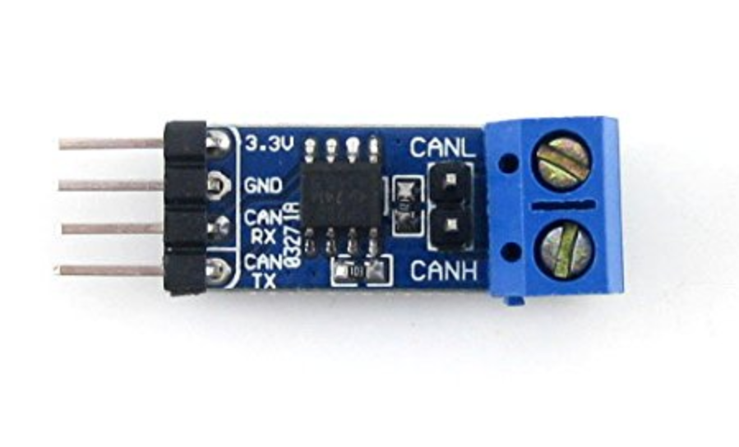

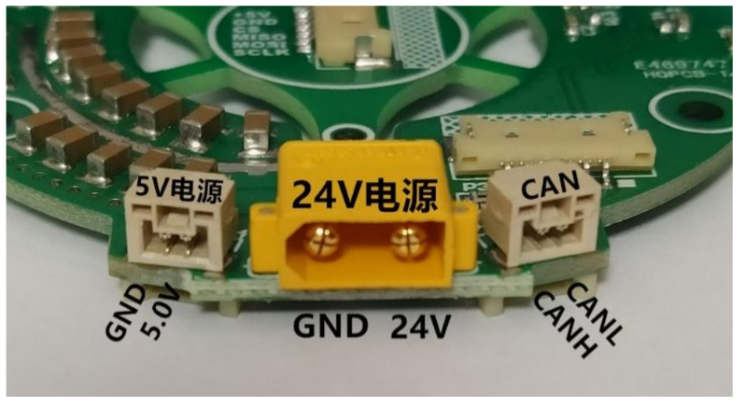

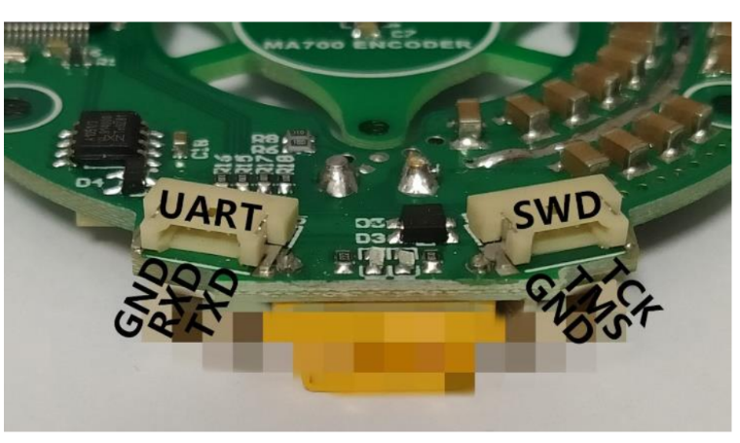

AliExpress source for the serial and prog cables.

<https://www.aliexpress.com/item/32902429074.html>

Serial port: 921600 baud, 8 bits, 1 stop bit, no parity bits

Picture of the controller. Note sure why the encoder is isolated and not connected on the PCB. It might be for thermal or mechanical isolation.

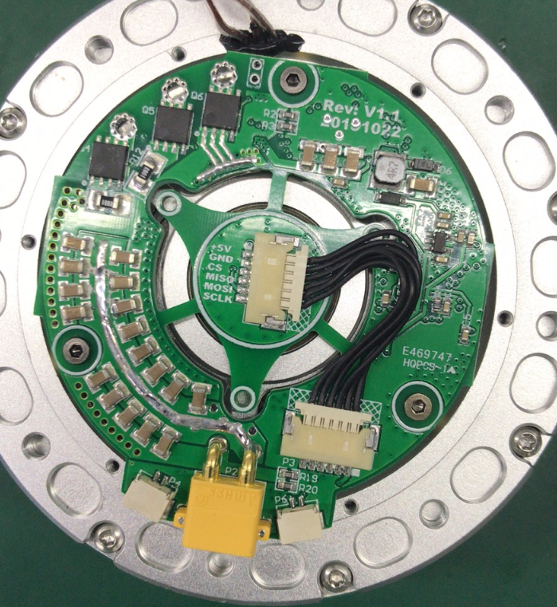

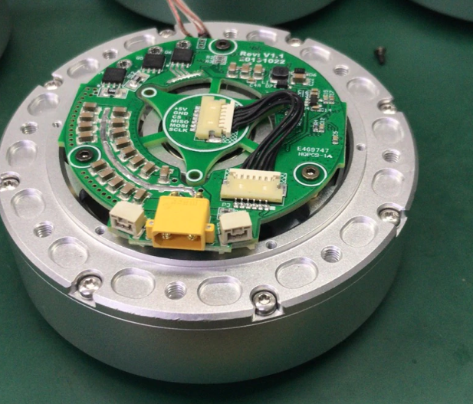

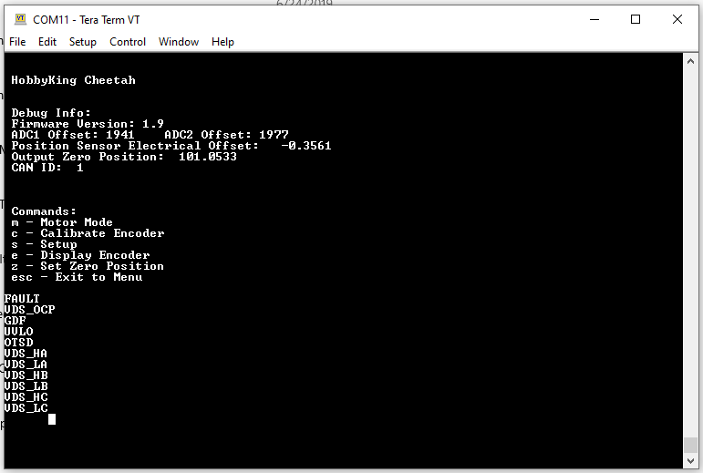

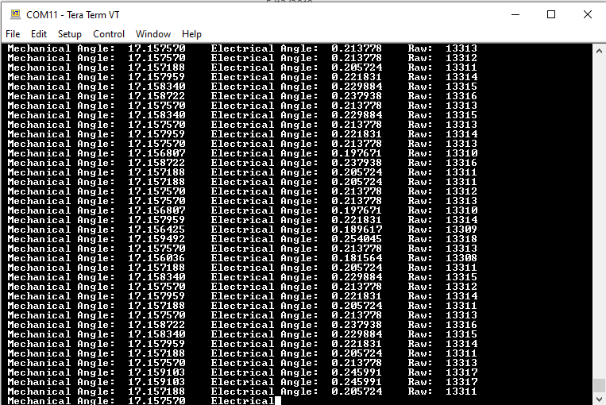

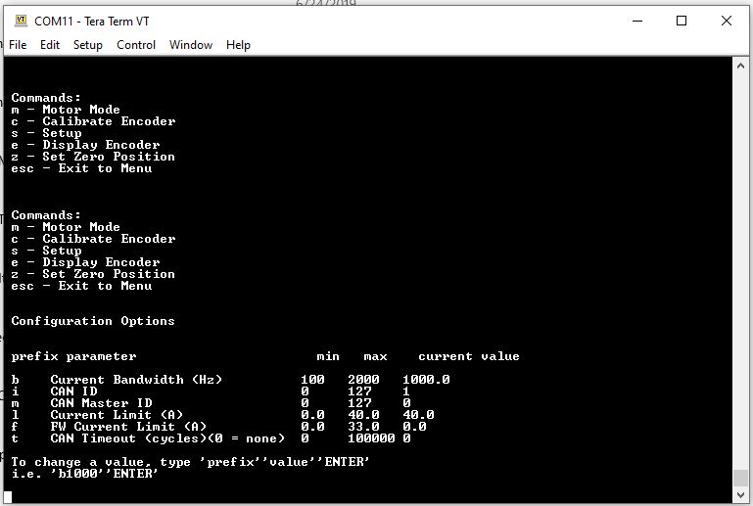

If only 5V is applied via the small 2 pin connector I get a continuous stream of faults on serial port….probably normal behavior.

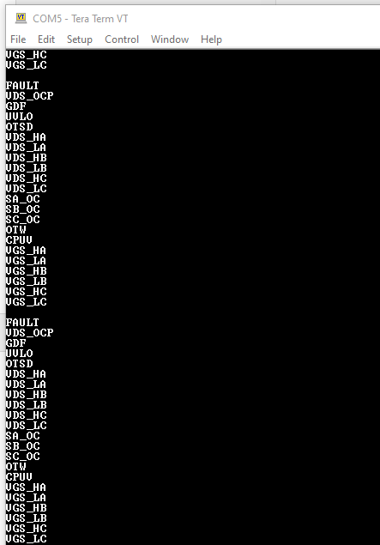

C# Test Program

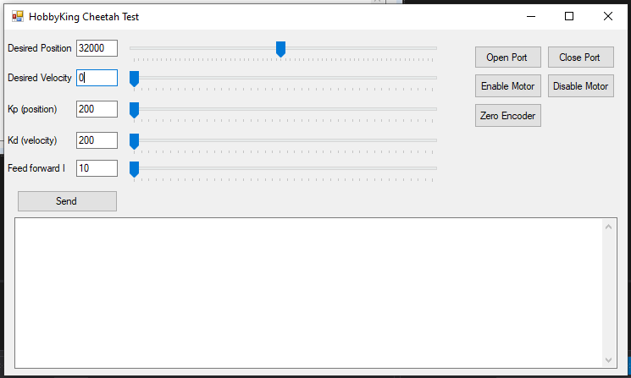

**Programing Firmware**

I am able to make basic changes to the firmware and upload them. [Here are some instructions](https://docs.google.com/document/d/14HLpJDV0MBez1FP9UIyuWOAR9XkmXL5tUZTvC5LI0m8/edit)

**Example...**

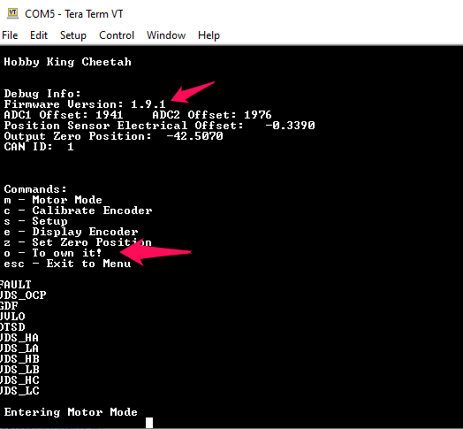

**How this will be used with Grbl_ESP32.**

The Cheetah motor works a bit like a hobby servo. It has a limited range in rotation and that range is mapped across a 16 bit address. That mapping range is adjustable in firmware, but I will use the existing range for now.

That 16 bit range will be mapped as steps in Grbl in machine space. You can use the steps/mm setting to set a real world unit like degrees. So G0X360 might move one revolution. Mapping in machine space will still allow you to zero the axis, but it will respect the range of the machine (ie motor)

At startup, or whenever Grbl is in stepper_idle mode the torque will be turned off. It will constantly read the Cheetah motor's position and update Grbl's axis location. This means you can manually move the motor and Grbl will track it.

When a Grbl move is made, stepper_idle ends, the torque is turned on and the Cheetah motor begins tracking Grbl's motion. At first, a high update rate (100Hz) of CAN messages will be used. This means the motor does not need to do a rapid uncontrolled move to Grbl's current position. It also means that the speed, position and acceleration of Grbl is tracked by the motor. Later, step/direction signals could be hacking to the firmware.

I hacked Grbl_ESP32 enough to demonstrate the motor. This is not final code, but functional. You can use it for reference. [See this file on a branch of the main code](https://github.com/bdring/Grbl_Esp32/blob/dynamixel_support/Grbl_Esp32/hk_cheetah.cpp).

**Step and Direction Control**

[Step and direction is now working.](http://www.buildlog.net/blog/2020/03/adding-step-and-direction-cnc-control-to-the-cheetah-motor/)

**Links to Progress Videos (Tweets)**

[Control](https://twitter.com/buildlog/status/1219807520816017409)

[Feedback](https://twitter.com/buildlog/status/1220372055776022528)

**Discussion**



If you have read this far you deserve a link to the [Slack Channel](https://join.slack.com/t/buildlog/shared_invite/enQtNjEzNjMwMTA3ODQ2LTZkMTE5MjcwZTY4MjgwOWEwMWE1MzZlNGNhNDdmMWEwNWZkN2Y5NjBlNjBlZjY2MTg3ZThlN2I3YjEwMzUyMWI). Use the bldc_servo_motors channel. **Lots of good stuff appearing on the Slack Channel !!!**

**Donation**

[](https://www.paypal.com/cgi-bin/webscr?cmd=_s-xclick&hosted_button_id=TKNJ9Z775VXB2)

If you consider this doc helpful, please consider a [donation to support my open source projects via PayPal](https://www.paypal.com/cgi-bin/webscr?cmd=_s-xclick&hosted_button_id=TKNJ9Z775VXB2)

**Suggestions**

I keep getting blank notices of suggestions. If you have a suggestion, do it on Slack.

**Extra Photos**

Here is a photo of my test rig. The motor needs a lot of weight to keep it from jumping around. Even with the weight of this 400 watt power supply it can do some serious jumps.

* ESP32 near the power plug is acting as a USB to CAN adapter. It goes through the skinny blue CAN PCB near the motor.
* The red PCB is a 3.3V FTDI USB UART that goes through a breadboard with some resistors. They limit the current, if I screw anything up playing with those pins.
* The blue dongle in the middle is the programmer.
* Not shown is another ESP32 running Grbl_ESP32 that generates step and direction signals. It plugs into the breadboard instead of the FTDI when in step/direction mode.

